**Pre-School Lunch Menu**

**June 2nd-11th**



Monday, June 2nd

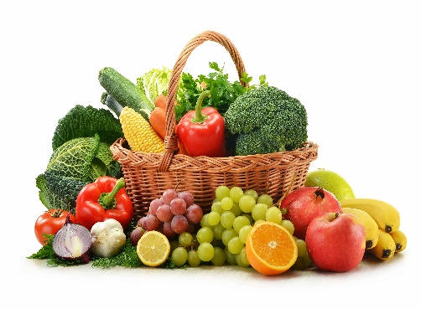 Cheese Quesadilla

Tuesday, June 3rd

Taco Snack

Wednesday, June 4th

Cheeseburger Sliders

Thursday, June 5th

 Turkey & Cheese Sandwich

Friday, June 6th

Pizza Party

Monday, Tuesday and Wednesday, June 9th, June 10th and 11th

Chef’s Choice

**All lunches are served with vegetables, fruit and milk**

Have a great summer 2025!

Jennifer Mullin, SNS Food Service Manager 856-582-4010